**HTML Paragraphs**

**Paragraph:**

A paragraph tag defines paragraph in HTML.

A paragraph always starts on a new line, and is usually a block of text.

The browsers automatically add some white space (a margin) before and after a paragraph.

**Code:**

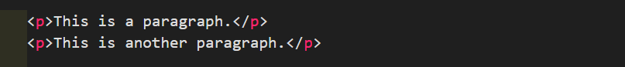

**Output:**

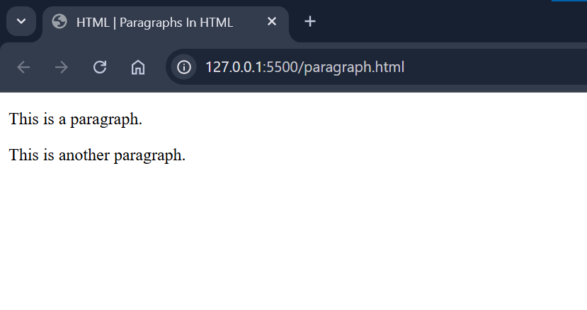

**HTML Display:**

You cannot be sure how HTML will be displayed.

Large or small screens, and resized windows will create different results.

With HTML, you cannot change the display by adding extra spaces or extra lines in your HTML code.

The browser will automatically remove any extra spaces and lines when the page is displayed:

**Code:**

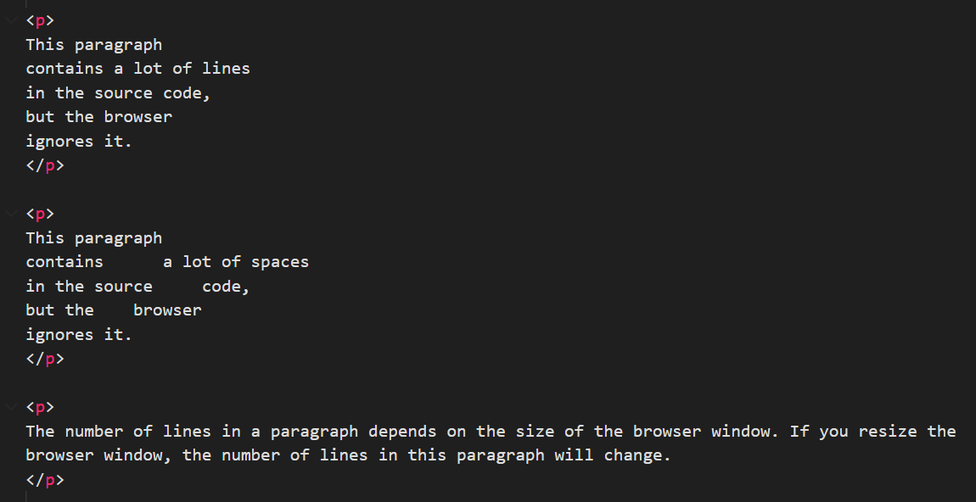

**Output:**

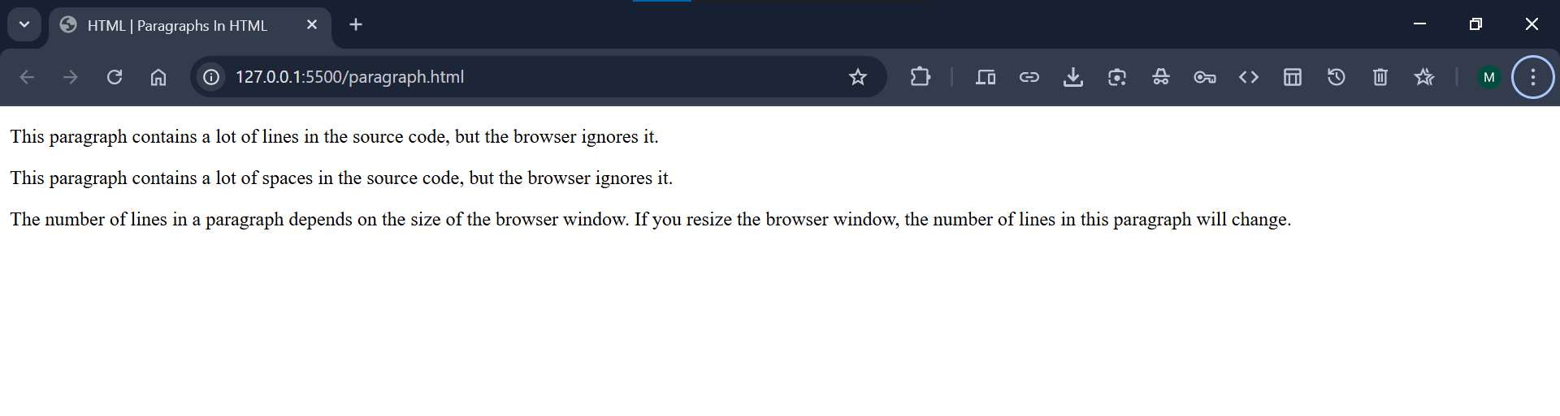

**Lorem:**

**Horizontal Rule Tag:**

The <hr> tag is called Horizontal Ruler.

The <hr> tag defines a thematic break or change in an HTML page.

The <hr> tag displays a horizontal line on the screen or a webpage.

It is also used to separate content (or define a change) in an HTML page:

The <hr> tag is an empty tag, which means that it has no end tag.

It is a block-level element.

**Code:**

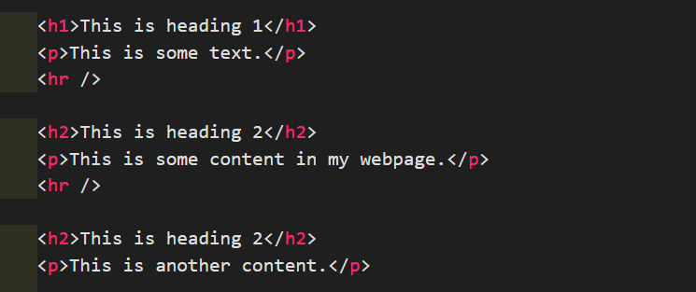

**Output:**

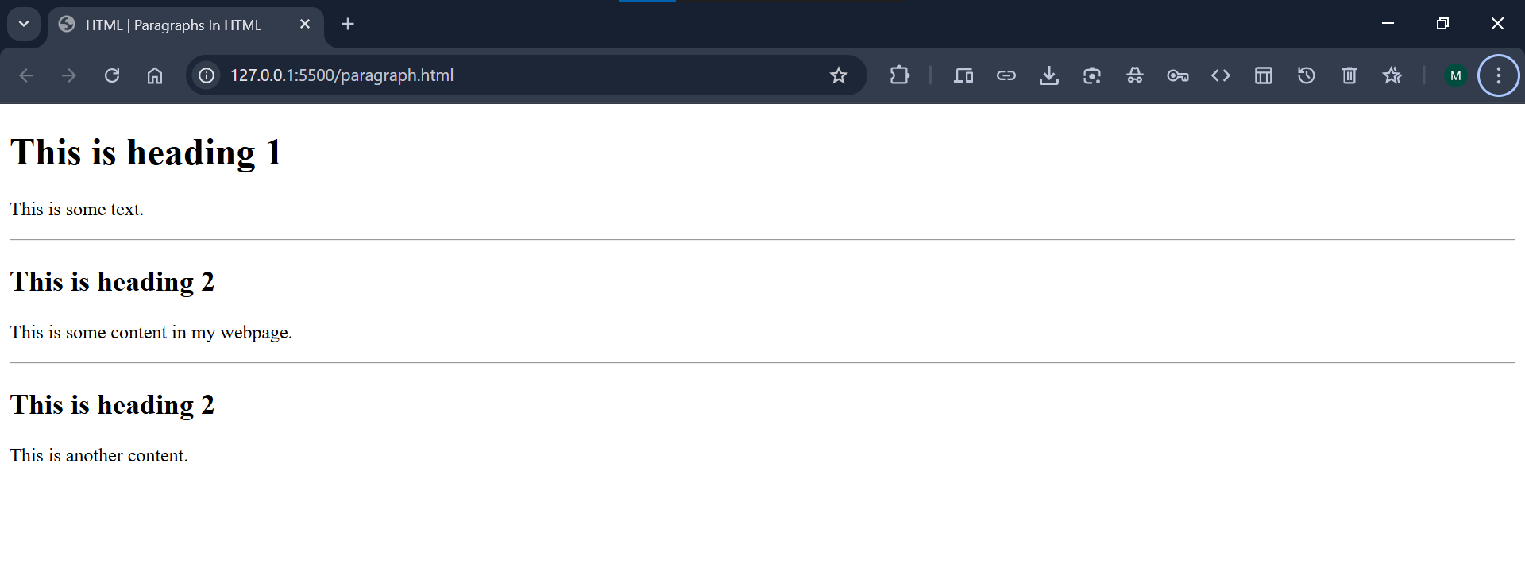

**Line Break Tag:**

The HTML <br> tag defines a line break.

Use <br> if you want a line break (a new line) without starting a new paragraph.

The HTML <br> tag is an empty tag, and it does not have a closing tag.

The HTML <br> tag is a block-level element.

**Code:**



**Output:**

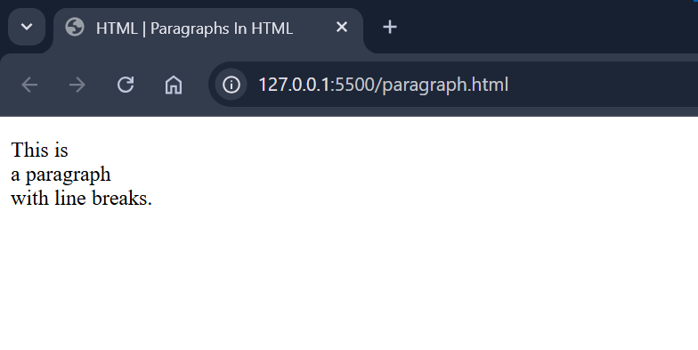

**The Poem Problem:**

This poem will display on a single line:

**Code:**

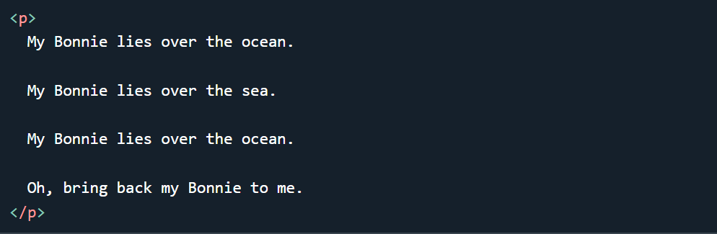

**Output:**

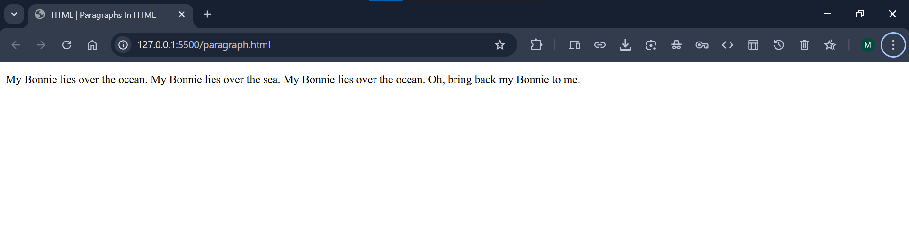

**Solution - The HTML <pre> Tag:**

The HTML <pre> element defines preformatted text.

The text inside a <pre> element is displayed in a fixed-width font (usually Courier), and it preserves both spaces and line breaks:

**Code:**

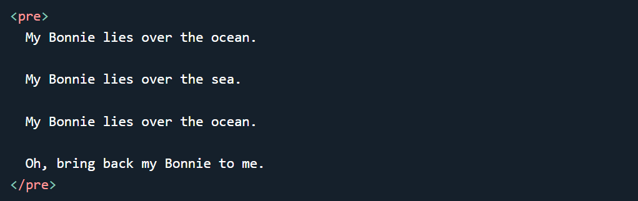

**Output:**

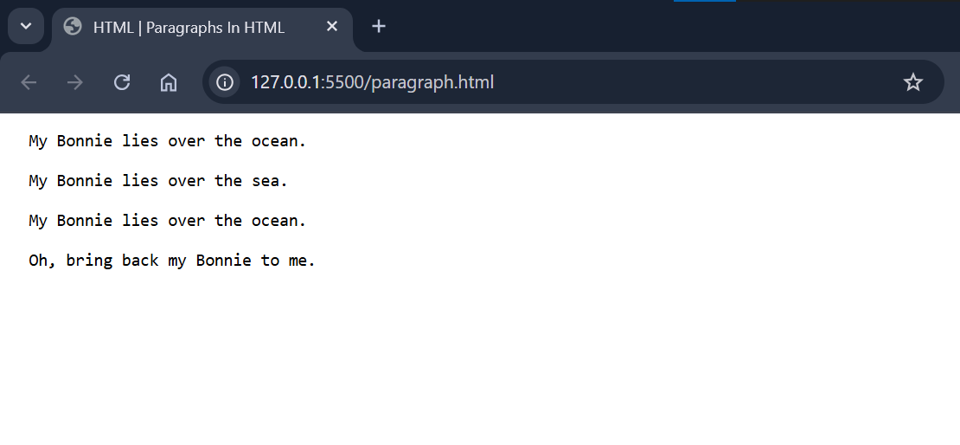

**HTML Tag Reference:**

W3Schools' tag reference contains additional information about HTML elements and their attributes.

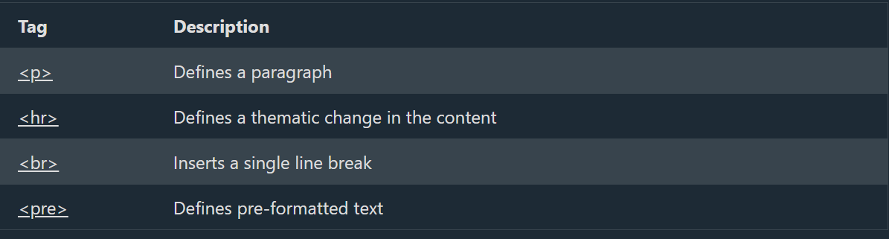

<https://www.w3schools.com/tags/tag_p.asp>

<https://www.w3schools.com/tags/tag_hr.asp>

<https://www.w3schools.com/tags/tag_br.asp>

<https://www.w3schools.com/tags/tag_pre.asp>